USER REQUIREMENTS

The Bidder should provide the following in the specified order in Section 4 of the proposal/bid document.

Provide detail information of the proposed solution as per document enclosed. Please note that marking should be carried out in the following manner; The Remarks column should be used to explain or provide detail information.

DESCRIPTION | REMARKS
Rating - 5 | If the User requirement is met 100% as defined in the RFP without any work around method.
Rating - 4 | If the User requirement is met 75% as defined in the RFP without any work around method. Define the number of hours required for the modification and cost in US$ in the Remarks column, in order to provide 100% functionality as defined.
Rating - 3 | If the User requirement is met 50% as defined in the RFP without any work around method. Define the number of hours required for the modification and cost in US$ in the Remarks column, in order to provide 100% functionality as defined.
Rating - 2 | If the User requirement is met 25% as defined in the RFP without any work around method. Define the number of hours required for the modification and cost in US$ in the Remarks column, in order to provide 100% functionality as defined.
Rating - 1 | If the User requirement is met as a Work around method defined in the RFP. Define the number of hours required for the modification and cost in US$ in the Remarks column, in order to provide 100% functionality as defined.
Rating - 0 | If the User requirement is not met as a defined in the RFP and modifications are required. Define the number of hours required for the modification and costs in US$ in the Remarks column.

The NBL rating is as follows:
1 = critical; 2 = essential; 3 = nice to have

CONSUMER CREDIT OPS (CPU) - CONTINGENT LIMIT LINES
Ref | Requirements | NBL Priority | Bidder Rating | Bidder’s Remarks
 | GENERAL REQUIREMENTS
 | Should have the flexibility of setting up of multiple loan products/ schemes | 1 | 5 | T24 enables a bank to design different products, combining all kinds of loaning with each other, creating the difference of product. The development of a new product is very simple, through the tools and subsystems available in T24 which are integrated in product package designed for the bank.
 | Should be able to identify the business line / Account officer at facility account level | 1 | 5 | Account officer is a mandatory field that should be filled. Beside main account officer, T24 provide another account officer field for user to fill other account officer  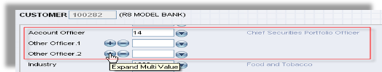  Figure 1. Account officer in customer level  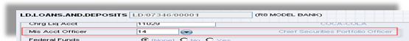  Figure 2. Account officer in loan level
 | In the event the facility being granted against a Deposit account the account pledged as collateral should be linked to the facility account and a lien created for the amount or percentage specified. | 1 | 5 | T24 has facility to attached deposit account as collateral. When there is a transaction to the deposit account, system will display an override message that the deposit is registered as collateral  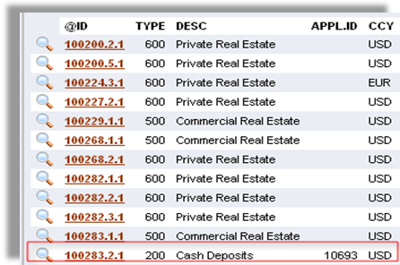  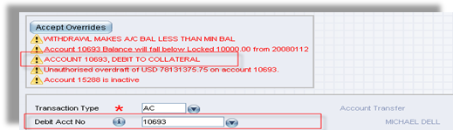  Figure 3. Transaction to deposit collateral  Collateral information can be access any time.
 | In the event the deposit under lien matures, the matured deposit should be renewed with lien and the new deposit details be updated to the loan contract. | 1 | 5 | Handled by T24 Collateral module.
 | Should be able to book more than one facility line for a customer | 1 | 5 | This is Supported by T24
 | Should be able to share collateral with another facility, provided that the amount pledged does not exceed the total deposit value | 1 | 5 | This is Supported by T24
 | Should be able to link more that one deposit account / Collateral to a single facility. | 1 | 5 | This is Supported by T24
 | Such lien marked should be reflected in the deposit account | 1 | 5 | Handled by the addition of a local reference field to mark the lien.
 | Limit lines should facilitate Multi currency values (i.e. if the LC is in USD facility line should be in LKR and the limit amount should be re-valued on a daily basis) |  | 5 | Supported by T24 Limit sub-system.
 | In the event of a Foreign Currency Deposit is pledged, Collateral valuation should be done by the system and any facility where there is in sufficient collateral be identified. | 1 |  | T24 has facility to have the online limit is fixed or variable. The underlying collateral should be recorded in the T24 Collateral Module.  The system recognizes two types of secured limit. A variable limit is one for which the system automatically allocates the value of any underlying collateral against the limit and calculates the ONLINE LIMIT amount on the basis of this secured amount. A fixed limit is similar, except that the value of the ONLINE LIMIT amount is never adjusted. In other words, the secured amount belonging to a fixed limit is calculated for information purposes but not for the system's limit checking.
 | Should be of both revolving and non-revolving nature. | 1 | 5 | This is Supported by T24
 | For Non-revolving lines the validity of the limit line should lapse once the facility utilized. I.e. LC is retired / |  | 5 | Supported by T24 Limit sub-system.
 | Should be able to view the history of amendments to facility line and details of transactions | 1 | 5 | This is Supported by T24
 | Flexibility to restrict products | 1 | 5 | This is Supported by T24
 | Ability to sub allocate facility lines | 1 | 5 | This is Supported by T24
 | Field to input free text | 1 | 5 | This is Supported by T24
 | MIS | 1 | 5 | This is Supported by T24
 | Audit activity trail | 1 | 5 | This is Supported by T24
 | Collateral shortfall report | 1 | 4 | All T24 applications and transactions can be retrieved easily by using enquiry designer, where the user can define what kind of information are needed to be printed in the reports or to be viewed

